

**CAPSTONE PROJECT REPORT**

**Report 3 – Software Requirement Specification**

– Hanoi, August 2019 –

**Table of Contents**

I. Project Report 3

1. Status Report 3

2. Team Involvements 3

3. Issues/Suggestions 3

II. Software Requirement Specification 4

1. Overall Description 4

1.1 Product Overview 4

1.2 Business Rules 5

2. User Requirements 6

2.1 System Actors 6

2.2 Use Cases 6

3. Functional Requirements 8

3.1 System Functional Overview 8

3.2 <<Feature Name 1>> 10

3.3 <<Feature Name 2>> 10

4. Non-Functional Requirements 11

4.1 External Interfaces 11

4.2 Quality Attributes 12

5. Other Requirements 14

5.1 Appendix1 - Messages List 14

5.2 Appendix2 - … 14

5.3 … 14

# I. Record of Changes

| **Date** | **A* M, D** | **In charge** | **Change Description** |
| --- | --- | --- | --- |
|  |  |  |  |
|  |  |  |  |
|  |  |  |  |
|  |  |  |  |
|  |  |  |  |
|  |  |  |  |
|  |  |  |  |
|  |  |  |  |
|  |  |  |  |
|  |  |  |  |
|  |  |  |  |
|  |  |  |  |
|  |  |  |  |

*A - Added M - Modified D - Deleted

# II. Software Requirement Specification

## 1. Product Overview

The All-in-One Wedding Platform is a comprehensive software system designed to streamline and enhance the wedding planning experience. It replaces the current fragmented and often manual processes used by couples, service suppliers, staff, and other stakeholders involved in wedding planning. The platform provides a unified interface for managing various wedding-related services, from booking and scheduling consultations to creating and approving quotes, managing payments, and more. The context diagram below illustrates the external entities and system interfaces for release 1.0. This system is designed to evolve over multiple releases, ultimately integrating with additional services such as third-party wedding planners, online payment gateways, and external promotion platforms.

>>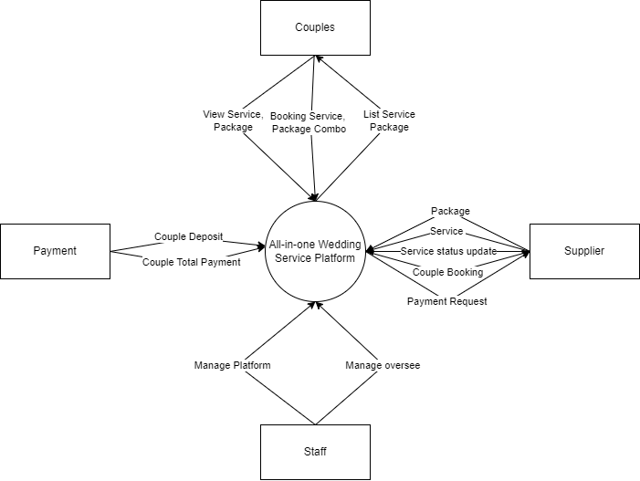

## 2. User Requirements

### 2.1 Actors

| **#** | **Actor** | **Description** |
| --- | --- | --- |
| 1 | Couples | Individuals or pairs who use the platform to search for, book, and manage various services for their wedding or other events. |
| 2 | Service Supplier | Businesses or individuals offering services (e.g., catering, photography, venue rental) who use the platform to advertise and manage their offerings. |
| 3 | Staff | Internal employees responsible for managing the platform, providing customer support, and ensuring the smooth operation of the services offered. |
| 4 | Admin | Individuals responsible for overseeing the entire system, including controlling access rights, data security, and maintaining the platform's performance. |

### 2.2 Use Cases

#### 2.2.1 Diagram(s)

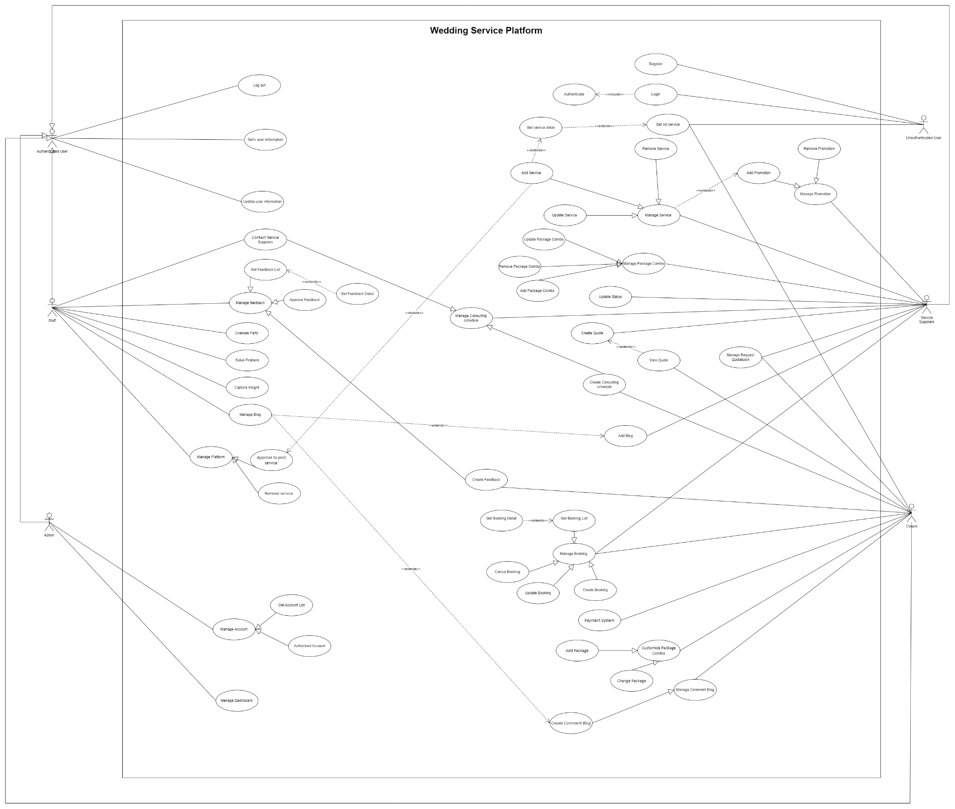

#### 2.2.2 Descriptions

| ID | Use case name | Actor | Description |
| --- | --- | --- | --- |
| UC_01 | Register | Guest | Allows a guest to create a new account on the platform by providing necessary information such as name, email, and password. |
| UC_02 | Login | Guest,  Couples,  Staff,  Service Suppliers,  Admin | Enables various users to log in to the platform using their credentials. Different roles will have access to different features based on their permissions |
| UC_03 | Get List Service | Guest,  Couples | Allows guests and couples to view a list of available wedding services offered by different service suppliers on the platform. |
| UC_04 | Get Service Detail | Guest,  Couples | Provides detailed information about a specific wedding service, including descriptions, pricing, and availability. |
| UC_05 | Manage Service | Service Suppliers | Enables service suppliers to add, update, or remove their wedding services listed on the platform. |
| UC_06 | Manage Package Combo | Service Suppliers | Allows service suppliers to create, update, or delete package combos that bundle multiple services together for couples. |
| UC_07 | Update Services Status | Service Suppliers | Lets service suppliers update the status of their services (e.g., available, booked, done) on the platform. |
| UC_08 | View Service Status | Service Suppliers,  Couples | Enables service suppliers and couples to view the current status of specific wedding services. |
| UC_09 | View Package Combo Status | Service Suppliers,  Couples | Allows service suppliers and couples to check the status of different package combos offered on the platform. |
| UC_10 | Manage Consulting Schedule | Service Suppliers | Enables service suppliers to organize and manage their consulting schedules, including setting available dates and times for consultations. |
| UC_11 | Create Consulting Schedule’s Information | Service Suppliers | Allows service suppliers to enter detailed information about their consulting schedules, such as topics covered and duration of consultations. |
| UC_12 | Approve Consulting | Service Suppliers | Enables service suppliers to approve consultation requests from couples. |
| UC_13 | Reject Consulting | Service Suppliers | Allows service suppliers to reject consultation requests from couples, providing reasons if necessary. |
| UC_14 | Create Consulting Schedule | Couples | Lets couples create a consultation schedule by selecting available slots provided by service suppliers. |
| UC_15 | View consulting schedule | Couples | Enables couples to view their scheduled consultations with service suppliers. |
| UC_16 | Create Booking Service | Couples | Allows couples to book specific wedding services from service suppliers on the platform. |
| UC_17 | Update Booking Service | Couples | Enables couples to modify their existing service bookings, such as changing the date or service details. |
| UC_18 | Cancel Booking Service | Couples | Allows couples to cancel their booked services with service suppliers on the platform. |
| UC_19 | Create Package Combo | Couples | Enables couples to create custom package combos by selecting multiple services from different suppliers. |
| UC_20 | Update Package Combo | Couples | Allows couples to modify their existing package combos, including adding or removing services. |
| UC_21 | Cancel Package Combo | Couples | Enables couples to cancel their custom package combos. |
| UC_22 | Create Quote | Service Suppliers | Allows service suppliers to create and send quotes to couples for requested services. |
| UC_23 | View Quote | Couples | Enables couples to view quotes provided by service suppliers for requested services. |
| UC_24 | Approve Quote | Couples,  Service Suppliers | Allows couples to approve received quotes, and service suppliers to confirm the approval. |
| UC_25 | Change Quote | Couples,  Service Suppliers | Enables both couples and service suppliers to negotiate and make changes to the quotes. |
| UC_26 | Get Booking Detail | Couples | Allows couples to view detailed information about their bookings, including service details and status. |
| UC_27 | Create Rating Service | Couples | Enables couples to rate the services they received from suppliers on the platform. |
| UC_28 | Create Feedback | Couples | Allows couples to provide feedback on the services and overall experience with the platform. |
| UC_29 | Manage Payment | Couples,  Service Supplier | Enables both couples and service suppliers to manage payments for services, including processing and tracking transactions. |
| UC_30 | Manage promotion | Service Supplier | Allows service suppliers to create and manage promotional offers for their services on the platform. |
| UC_31 | Post wedding blog | Service Supplier | Enables service suppliers to post blog articles related to weddings, such as tips, trends, and success stories. |
| UC_32 | Approve wedding blog | Staff | Allows staff to review and approve wedding blog posts submitted by service suppliers before they are published. |
| UC_33 | Reject wedding blog | Staff | Enables staff to reject wedding blog posts submitted by service suppliers, providing reasons for the rejection. |
| UC_34 | Contact service suppliers | Staff | Allows staff to communicate with service suppliers for various administrative and operational purposes. |
| UC_35 | Manage platform | Staff,  Admin | Enables staff and administrators to manage and oversee the entire platform, including user management, service listings, and content. |
| UC_36 | Approve post service | Staff,  Admin | Allows staff and administrators to review and approve new service listings submitted by suppliers before they are published. |
| UC_37 | Cancel post service | Staff,  Admin | Enables staff and administrators to cancel or remove service listings from the platform. |
| UC_38 | Manage rating | Staff | Allows staff to oversee and manage service ratings provided by couples, ensuring fairness and appropriateness. |
| UC_39 | Monitor Request | Staff | Enables staff to monitor various requests made on the platform, such as service inquiries, consultations, and bookings. |
| UC_40 | Oversee Party | Staff | Allows staff to oversee and coordinate wedding events and parties booked through the platform, ensuring smooth operations. |
| UC_41 | Solve Problem | Staff | Enables staff to address and resolve any issues or problems reported by users or encountered during service provision. |
| UC_42 | Capture Insight | Staff | Allows staff to gather and analyze data insights from the platform to improve services and user experience. |
| UC_43 | Manage Account | Admin | Enables administrators to manage user accounts, including creating, updating, and deleting accounts. |
| UC_44 | Manage Dashboard | Admin | Allows administrators to manage and customize the platform's dashboard, including key metrics and analytics. |
| UC_45 | Manage Service Suppliers’s Dashboard | Service Supplier | Enables service suppliers to manage their dashboard, providing insights into their service performance and customer interactions. |
| UC_46 | Get user’s information | Authenticated user | Allows authenticated users to view their personal information stored on the platform. |
| UC_47 | Update user’s information | Authenticated user | Enables authenticated users to update their personal information on the platform. |
| UC_48 | Mange Comment Blog | Staff | Allows staff to manage comments on wedding blogs, ensuring they are appropriate and relevant. |
| UC_49 | Manage Blog | Staff | Enables staff to manage all blog content on the platform, including approving, editing, and deleting posts. |
| UC_50 | Manage Request Quotation | Service Supplier | Allows service suppliers to manage quotation requests received from couples, including creating and updating quotes. |
| UC_51 | Log out | Authenticated user | Enables authenticated users to log out of the platform securely. |

## 3. Functional Requirements

### 3.1 System Functional Overview

#### 3.1.1 Screens Flow

#### 3.1.1.1 Couples

## 

***3.1.1.2 Suppliers***

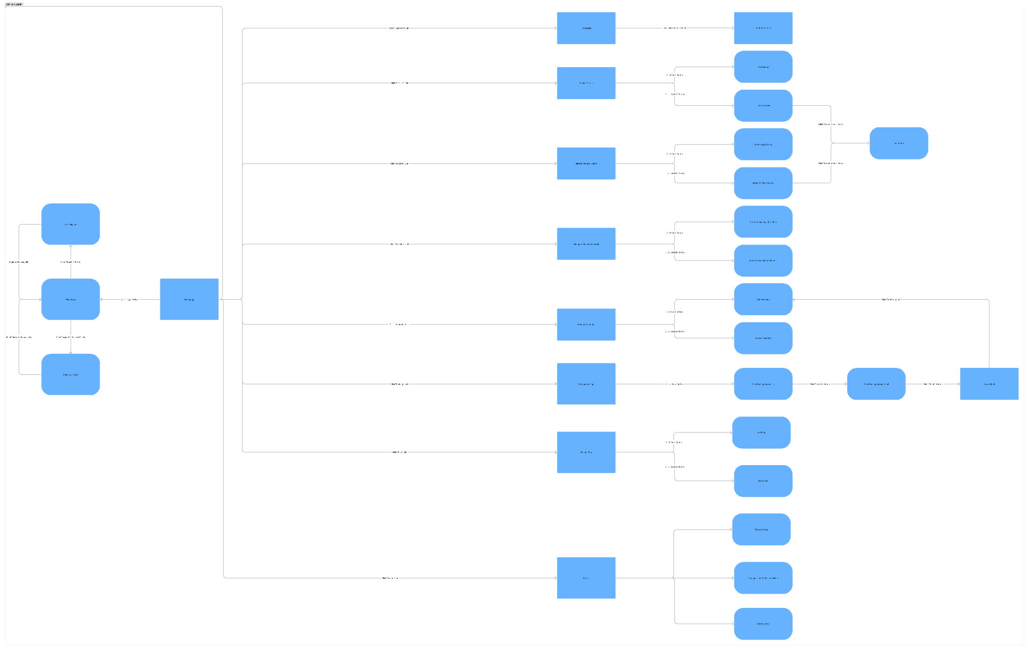

***3.1.1.3 Staff***

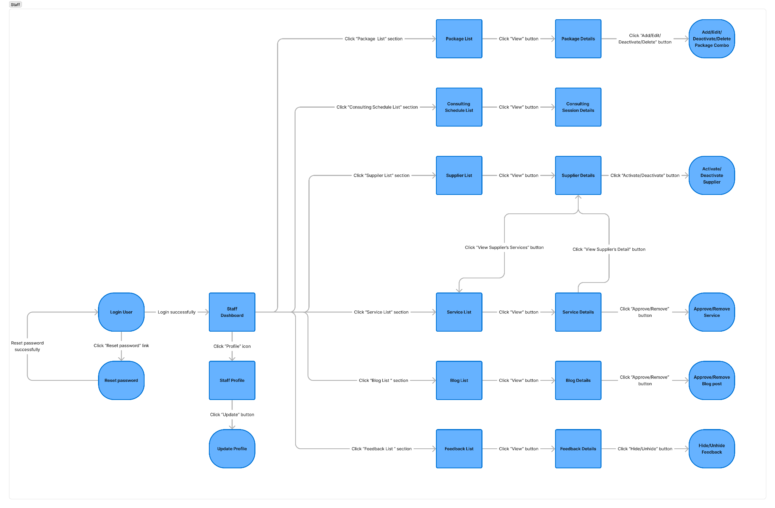

***3.1.1.4 Admin***

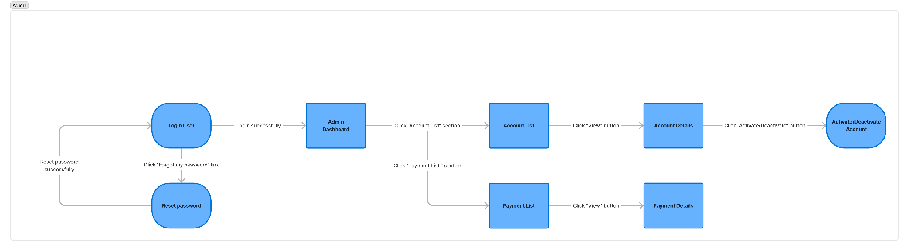

***3.1.1.5 Guest***

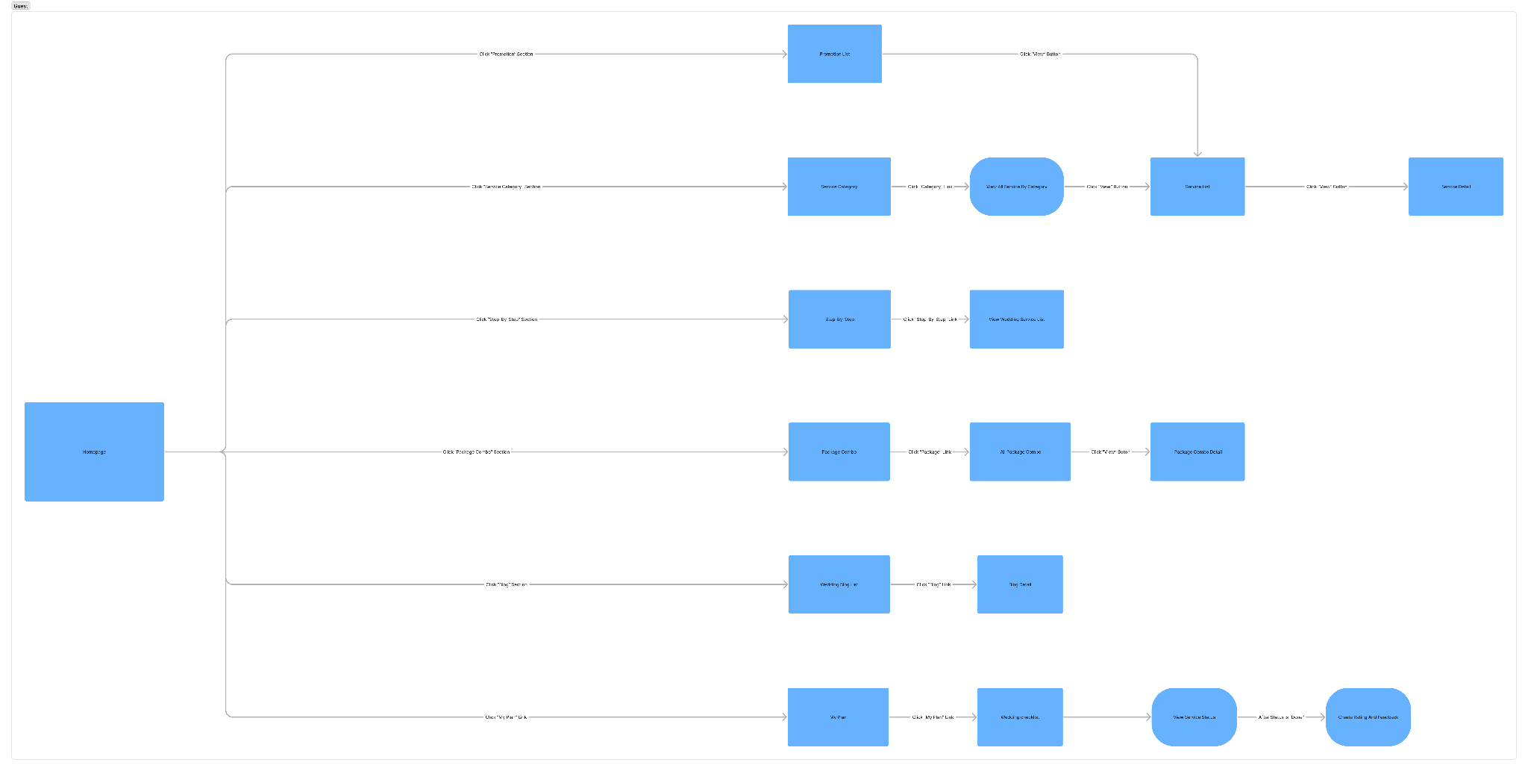

#### 3.1.2 Screen Descriptions

| **#** | **Feature** | **Screen** | **Description** |
| --- | --- | --- | --- |
| 1 | Manage Account | Register | <<Screen Brief description>> |
| 2 | Manage Account | Login |  |
| 3 | Manage Account | Forgot password |  |
| 4 | Manage |  |  |
|  |  |  |  |
|  |  |  |  |
|  |  |  |  |

#### 3.1.3 Screen Authorization

| **Screen** | **Role-Name1** | **Role-Name2** | **Role-Name3** | **…** |
| --- | --- | --- | --- | --- |
| <<Screen Name1>> | X |  | X | X |
| <<Screen Activity>> |  |  | X | X |
| <<Screen Name2>> | X |  | X |  |
| Query All Data | X |  |  |  |
| Query Own Data |  |  | X |  |
| Query Managed Data |  |  | X |  |
| Add New Data |  |  | X | X |
| Update All Data |  |  |  | X |
| Update Own Data |  |  |  | X |
| Update Managed Data |  |  |  | X |
| Delete Data |  |  |  |  |
| … |  |  |  |  |

#### 3.1.4 Non-Screen Functions

*[Provide the descriptions for the non-screen system functions, i.e batch/cron job, service, API, etc.]*

| **#** | **Feature** | **System Function** | **Description** |
| --- | --- | --- | --- |
| 1 | <<Feature Name>> | <<Function Name1>> | <<Function Name1 Description>> |
| 2 | … |  |  |

#### 3.1.5 Entity Relationship Diagram

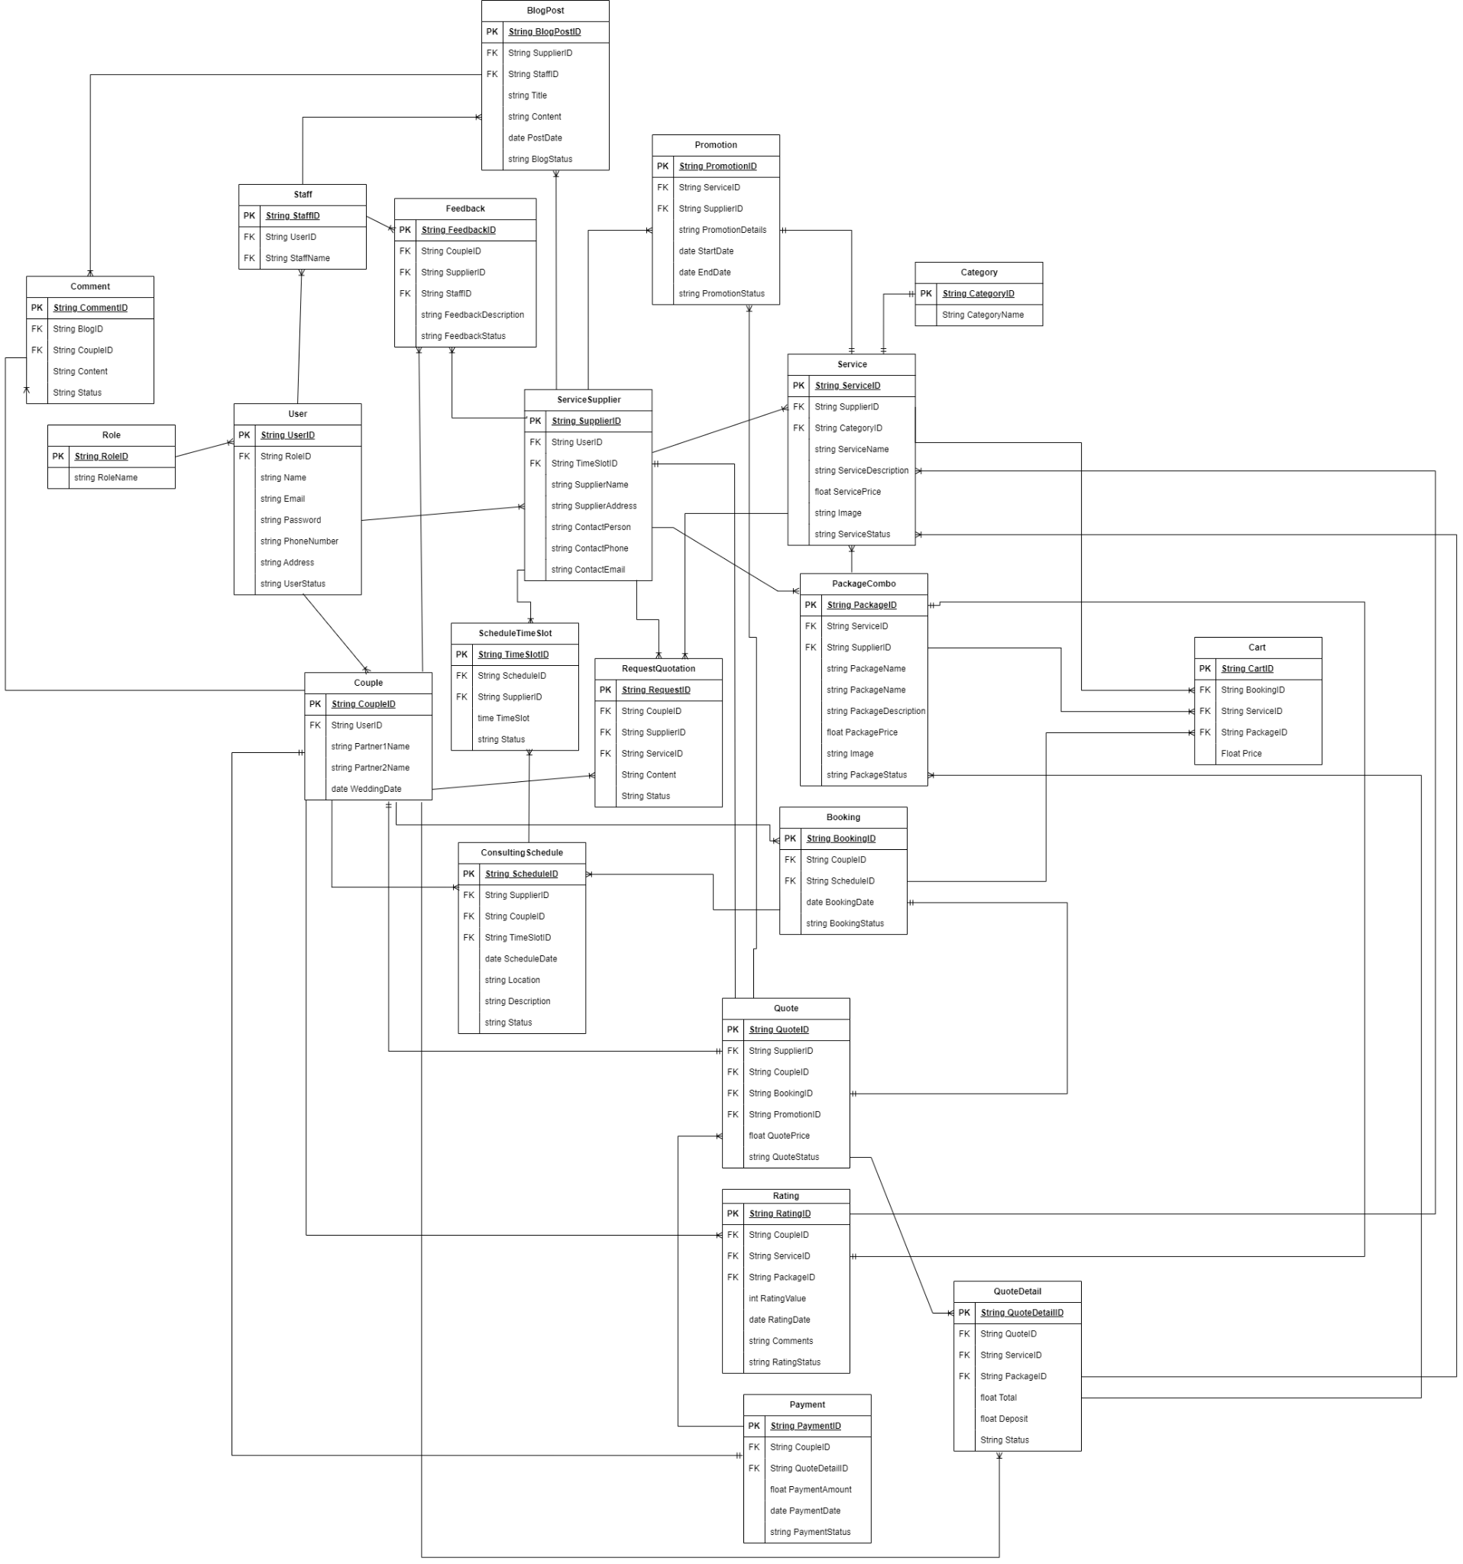

**Entities Description**

| **#** | **Entity** | **Description** |
| --- | --- | --- |
| 1 | Role | Represents different user roles within the platform such as admin, couple, service supplier, or staff. |
| 2 | User | Contains details about users registered on the platform, including their personal information and role. |
| 3 | Couples | Stores information about couples who are planning their wedding, including preferences and wedding details. |
| 4 | Service Suppliers | Contains details of service providers such as florists, caterers, photographers, etc., who offer services through the platform. |
| 5 | Staff | Information about the staff members who work for the platform or are involved in organizing the wedding. |
| 6 | ScheduleTimeSlot | Represents the available time slots for different services and consultations offered by service suppliers and staff. |
| 7 | ConsultingSchedule | Manages the schedules for consultations between couples and service suppliers or staff. |
| 8 | Service | Details about the individual services offered by suppliers, such as catering, decoration, photography, etc |
| 9 | PackageCombo | Information about bundled service packages offered at a combined price for convenience and cost savings. |
| 10 | Booking | Manages the bookings made by couples for various services and packages. |
| 11 | Quote | Represents the quotations provided by service suppliers to the couples based on their requirements. |
| 12 | Rating | Stores ratings and reviews given by couples for the services and service suppliers. |
| 13 | Payment | Manages payment transactions made by couples for bookings and services. |
| 14 | QuoteDetail | Detailed information about each quote, including services, pricing, and terms. |
| 15 | Category | Classification of services into different categories such as catering, photography, venue, etc. |
| 16 | Promotion | Information about any promotional offers or discounts available on the platform. |
| 17 | Feedback | Stores feedback from couples about the platform and its services. |
| 18 | BlogPost | Articles and blog posts related to wedding planning, trends, tips, and inspiration. |
| 19 | Comment | Comments made by users on blog posts and articles. |
| 20 | Cart | Temporary storage for services and packages that couples are considering for booking. |
| 21 | Request Quotation | Requests made by couples to service suppliers for quotations based on their specific needs and preferences. |

### 3.2 <<Feature Name 1>>

#### 3.2.1 <<Function Name 1>>

*[A function can be a screen or a non-screen function (listed in the part 3.1.5 above). In this part, you need to provide the details on the related function, focus on mentioning below information*

* *Function trigger: how this function is triggered (navigation path, a timing frequency, etc.*
* *Function description: actors/roles, purpose, interface, data processing, etc.*
* *Screen layout: mock-up prototype of the screen, sample below is for Manage Products screen*

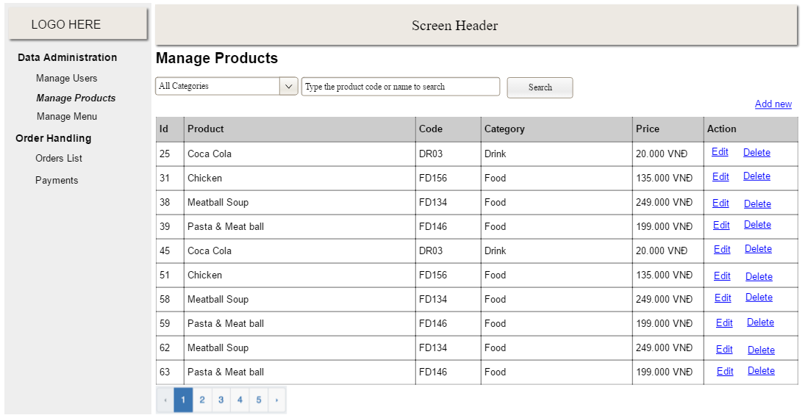

* *Function Details: provide explanation for the data, validation, business rules, functionalities (for both normal cases and abnormal cases), etc. of the function so that the reader can image how it work.*

*]*

#### 3.2.2 <<Function Name 2>>

…

### 3.3 <<Feature Name 2>>

…

## 4. Non-Functional Requirements

### 4.1 External Interfaces

N/A

### 4.2 Quality Attributes

#### 4.2.1 Usability

NFR-01: The system interface should be intuitive and user-friendly to ensure ease of use for individuals with varying levels of technical expertise, including couples planning their weddings.

NFR-02: Users should have the ability to adjust settings for their individual profiles, such as preferred vendors, budget tracking methods, and guest list management tools, to enhance usability and meet their specific wedding planning needs.

#### 4.2.2 Reliability

NFR-03: The system should have a minimum uptime of 99.9% to ensure that users can access the website and utilize its features without interruption, particularly during critical wedding planning moments.

NFR-04: Data stored in the system should be encrypted and protected against data corruption or unauthorized access to maintain the trust and reliability of the platform for users.

#### 4.2.3 Performance

NFR-05: The system should be capable of handling concurrent user interactions and data processing during peak wedding planning seasons without experiencing significant slowdowns or performance degradation.

## 5. Requirement Appendix

### 5.1 Business Rules

| ID | Rule Description |
| --- | --- |
| BR-01 | Username must be unique. |
| BR-02 | Only 1 account can be registered per email. |
| BR-03 | Passwords must contain at least 8 characters. |
| BR-04 | User must accept our terms and privacy policy to be able to create an account. |
| BR-05 | The account must perform email verification. |
| BR-06 | New password must not match the current password. |
| BR-07 | Guests and Couples can view the list of available services and detailed information about each service. |
| BR-08 | Only Service Providers can add and update of the services they provide |
| BR-09 | Service adds, updates must be approved by Admin or Staff before becoming visible to users |
| BR-10 | Service Suppliers can update the status of their services to "available," "booked," or "unavailable." |
| BR-11 | Couples can view the status of services they are interested in. |
| BR-12 | Service Suppliers can create and manage package combos with multiple services offered |
| BR-13 | Couples must adhere to the booking procedures established on the platform, including the use of in-platform communication tools for initial contacts and negotiations with Service Suppliers. |
| BR-14 | All booking agreements, including changes in service terms and additional requests, must be documented through the platform to ensure they are honored and traceable. |
| BR-14 | Couples are required to make payments according to the payment terms specified by the Service Suppliers, which must comply with the platform’s overall payment policies. |
| BR-15 | The platform may provide escrow services to hold payments until services are rendered, ensuring financial security for both parties. |
| BR-16 | All financial disputes should be reported through the platform’s dispute resolution center. |
| BR-17 | Couples should communicate respectfully and clearly with Service Suppliers, adhering to response time guidelines set by the platform to foster good relations and efficient service provision. |
| BR-18 | Couples must follow the platform’s cancellation policy. Any cancellations or modifications to the service agreement should be made within the time frame allowed by the policy to avoid penalties. Flexible Cancellation:   * Couples may cancel their booking up to 30 days before the event date without any penalty. * Cancellations made 15-29 days before the event date will incur a 25% cancellation fee based on the total service cost. * Cancellations made 7-14 days before the event date will incur a 50% cancellation fee. * Cancellations less than 7 days before the event date will not be honored.   Exceptions:   * Special circumstances such as illness or unforeseen events leading to cancellation may be considered for partial or full refunds at the discretion of the vendor, supported by valid documentation. |
| BR-19 | In the case of unforeseen circumstances leading to cancellations or significant modifications, couples are advised to communicate with the vendor and the platform as soon as possible. |
| BR-20 | Couples must not share sensitive information with Service Suppliers outside of what is necessary for service provision. |
| BR-21 | The platform guarantees the confidentiality of personal data shared through its systems, in compliance with data protection laws. |
| BR-22 | Couples are expected to adhere to all platform policies, including those regarding non-discrimination and community standards. |
| BR-23 | Violations of platform rules may lead to account suspension or additional penalties. |
| BR-24 | The platform may offer planning tools, checklists, and guides, which couples are encouraged to use to enhance their planning experience. |
| BR-25 | Misuse of any platform resources or tools will be subject to review and potential action. |
| BR-26 | The platform is not liable for any direct damages or losses incurred from vendor services but will assist in mediation and resolution where possible |
| BR-27 | All services listed must be accurately described, including all fees and any required deposits or additional charges. |
| BR-28 | Promotions must be clear and truthful, and not misleading to Couples. |
| BR-29 | Service Suppliers must adhere to platform guidelines for any special offers or discounts to avoid false advertising claims. |
| BR-30 | Service Suppliers must confirm bookings in a timely manner as specified by platform policies. |
| BR-31 | Availability for services must be managed and updated regularly to reflect true open dates to prevent overbooking. |
| BR-32 | Service Suppliers must honor all bookings as agreed upon unless significant circumstances arise, in which case the platform should be notified immediately. |
| BR-33 | Communication must be professional, timely, and via the platform’s designated channels to ensure documentation and oversight. |
| BR-34 | Service Suppliers must provide clear, accurate, and timely responses to client inquiries and requests. |
| BR-35 | Service Suppliers are expected to handle all client interactions with courtesy and respect, adhering to customer service best practices. |
| BR-36 | Service Suppliers agree to the platform’s payment terms, including any fees or commissions associated with the use of the platform. |
| BR-37 | All financial transactions must be processed through the platform to ensure security and proper record-keeping. |
| BR-38 | Service Suppliers are responsible for adhering to all applicable tax laws and financial regulations. |
| BR-39 | Service Suppliers must have a clear and fair cancellation policy, which must be communicated to clients prior to booking. Flexible Cancellation:   * Service Suppliers may cancel service up to 30 days before the event date without penalty. * Cancellations 15-29 days prior to the event date will incur a 25% cancellation fee based on the total service cost. * Cancellations 7-14 days before the event date will incur a 50% cancellation fee. * Cancellations less than 7 days before the event date will not be honored.   Assistance in finding a comparable service provider through the platform, subject to availability. |
| BR-40 | Service Suppliers must accept and encourage honest client feedback. |
| BR-41 | Negative feedback should be addressed promptly and effectively to improve service quality and client satisfaction. If that Service Provider receives:   * Negative feedback 1-3 times will receive a warning from the platform * Negative feedback 4 times will result in your account being banned from the platform for 10 days * Negative feedback more than 4 times will have your account permanently banned from the system |
| BR-42 | Service Suppliers must comply with all local and national laws regarding their services, including health and safety standards. |
| BR-43 | Ethical business practices must be upheld, including non-discrimination and the protection of client privacy. |
| BR-44 | Service Suppliers must engage in the platform’s dispute resolution process in good faith to resolve conflicts with clients. |
| BR-45 | The platform may mediate disputes, but Service Suppliers are encouraged to resolve issues directly with clients whenever possible. |
| BR-46 | Service Suppliers are encouraged to participate in platform updates, training, and community engagements to stay informed about best practices and platform enhancements. |
| BR-47 | Active and positive participation in the platform community is expected, as it enhances vendor reputation and client trust. |
| BR-48 | Failure of clients to show up on the event day without prior cancellation will result in a 100% charge of the booked service cost. |
| BR-49 | Service Suppliers who fail to provide the booked service without prior cancellation will face penalties such as refund demands and potential suspension from the platform. |
| BR-50 | Clients may request modifications to their bookings (e.g., change of date or adjustments to service) up to 15 days before the event without any penalties, subject to vendor availability. |
| BR-51 | The platform reserves the right to update this cancellation policy at any time. Changes will be communicated to all registered users and will apply to bookings made after the date of change. |

### 5.2 Common Requirements

*[Fill all the common requirements here..]*

### 5.3 Application Messages List

| **#** | **Message code** | **Message Type** | **Context** | **Content** |
| --- | --- | --- | --- | --- |
| 1 | MSG01 | In line | There is not any search result | *No search results.* |
| 2 | MSG02 | In red, under the text box | Input-required fields are empty | *The * field is required.* |
| 3 | MSG03 | Toast message | Updating asset(s) information successfully | *Update asset(s) successfully.* |
| 4 | MSG04 | Toast message | Adding new asset successfully | *Add asset successfully.* |
| 5 | MSG05 | Toast message | Confirming email of asset hand-over is sent successfully | *A confirmation email has been sent to {email_address}.* |
| 6 | MSG06 | Toast message | Resetting asset information successfully | *Return asset(s) successfully.* |
| 7 | MSG07 | Toast message | Deleting asset information successfully | *Delete asset(s) successfully.* |
| 8 | MSG08 | In red, under the text box | Input value length > max length | *Exceed max length of {max_length}.* |
| 9 | MSG09 | In line | Username or password is not correct when clicking sign-in | *Incorrect user name or password. Please check again.* |

### 5.4 Other Requirements…